IRON MOUNTAIN — At the halfway point of a 10-year effort by Wisconsin Department of Natural Resources Fisheries to restore sections of the Menominee River basin to self-sustaining walleye populations, Wildlife Unlimited of Dickinson County has fulfilled its financial commitment to the project.

With substantial support as well from the We Energies Mitigation and Enhancement Fund, the project was launched in 2018 with walleye stocking in the Twin Falls and Kingsford flowages.

The original scope of the plan was to have Wisconsin DNR Fisheries work with Mole Lake Hatchery in Crandon, Wis., to raise the specific strain of walleye indigenous to the Menominee River system, said Wisconsin DNR Fisheries biologist Greg Matzke from the field office in Florence, Wis. In this way, unlike in usual put-and-take stockings, the fish would have a greater chance of naturally reproducing.

In addition, larger, heartier and more costly 7- to 9-inch fingerlings were raised and stocked to increase the likelihood of survival as these fish adjusted to their new environment.

Knowing the recreational significance of these two boundary waters, Wildlife Unlimited approached Wisconsin DNR Fisheries to see if there were some way the organization could participate and enhance the project. Matzke had indicated the stocking plan was initially set to occur every other year for the next decade.

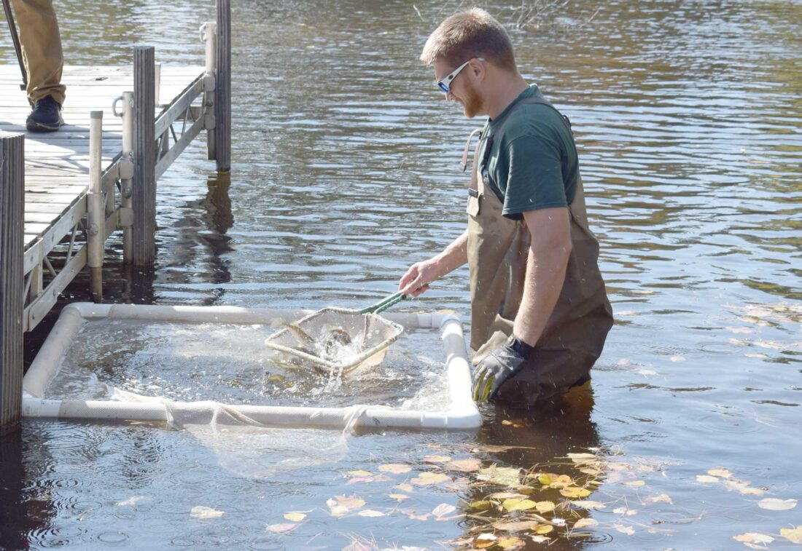

WISCONSIN DNR FISHERIES biologist Greg Matzke prepares to release 7- to 9-inch walleye fingerlings into the Menominee River as part of a restocking plan partially funded by Wildlife Unlimited of Dickinson County. (Marguerite Lanthier/Daily News photo)

He revised the plan to allow Wildlife Unlimited and WeEnergies to fund two odd-year stockings during the first five years, effectively creating annual stockings during the first half of the project’s timeline. These additional stockings are mean to bolster the effort to one day establish self-sustaining walleye fisheries in these two waterways.

On Tuesday, more than 14,000 additional fingerlings were stocked in Twin Falls and Kingsford flowages, funded entirely by Wildlife Unlimited and We Energies. Members of Wildlife Unlimited’s board of directors were there to observe the release of the fingerlings.

*“We are certainly grateful to these folks for lending a hand to this effort,”* Matzke said. *“Despite a lot of research, planning and time on the water, nothing in major efforts of this type is guaranteed to be successful. However, we remain hopeful that we will be successful at some significant level.”*

Matzke went on to say he and his fisheries team will be conducting extensive monitoring of survival and reproduction during the next stage of the plan as stocked fish reach adult age.

*“This effort to restore the walleye fishery in these flowages is a serious one and involves a lot of people,”* said Mole Lake Hatchery’s general manager Mike Preul, who oversaw the stocking. *“My team and I work meticulously to raise substantial numbers of healthy walleyes for this project. There is a good amount of science applied throughout the rearing process.”*

Reflecting the serious commitment of the joint effort, Preul then introduced Dr. D.F. Deng from the School of Freshwater Sciences at the University of Wisconsin-Milwaukee, who has been closely monitoring the work. Deng is a fisheries nutrition researcher who collaborates with Mole Lake Hatchery to optimize their feeding strategies to support walleye fingerling production.

The rehabilitation plan for the Twin Falls and Kingsford flowages fits within Wisconsin DNR’s larger management plan for the entire watershed. These two sections of the Menominee River Basin were once highly valued by walleye anglers on both sides of the Wisconsin-Michigan border. However, over the past few decades these fisheries had received little management oversight, to a point where only small populations of walleye were being sustained through natural reproduction.

*“This project reflects the very essence of our 40-year mission to enhance the outdoor experience for the people of our area,”* said Mike Lavarnway, Wildlife Unlimited’s incoming president. *“It could not happen without the good science and expertise of Wisconsin DNR Fisheries and Mole Lake Hatchery.”*

Lavarnway added, *“And, very importantly, we could not participate in this multi-year effort without the financial support of our valued partner, We Energies, and the ongoing support of our Wildlife Unlimited members. Hopefully, we can all look back in the coming years with great satisfaction knowing we have contributed to the successful restoration of productive and self-sustaining walleye fisheries in our area.”*